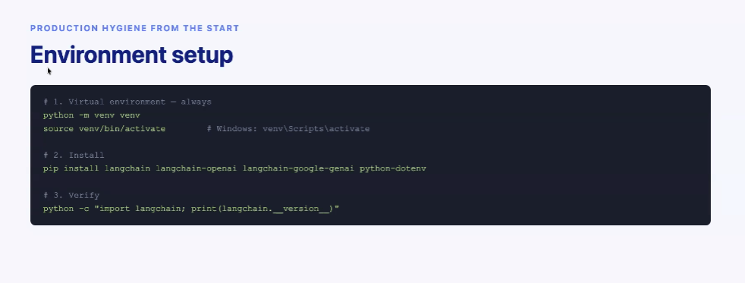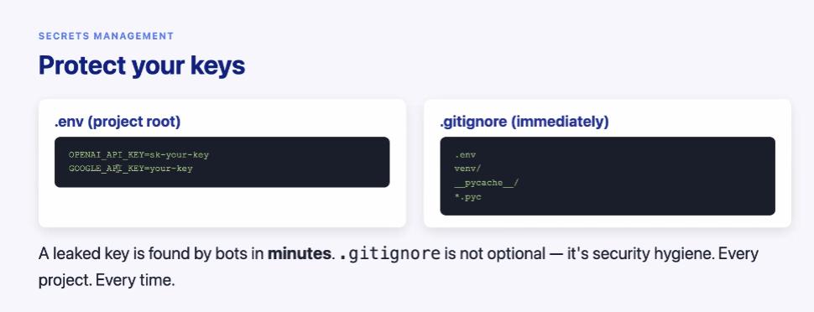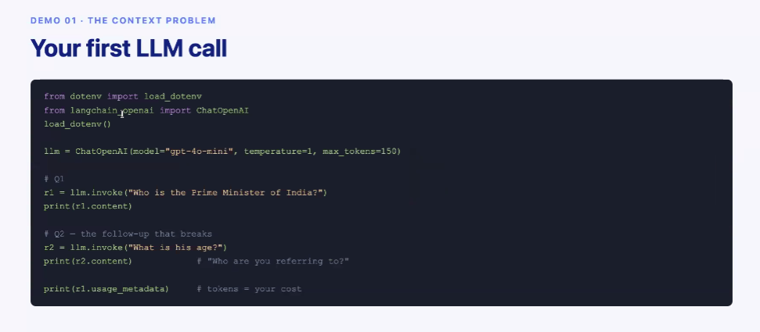
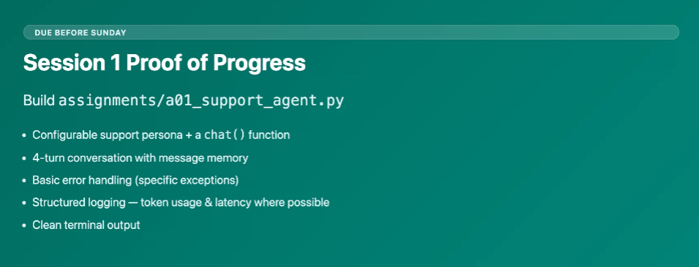

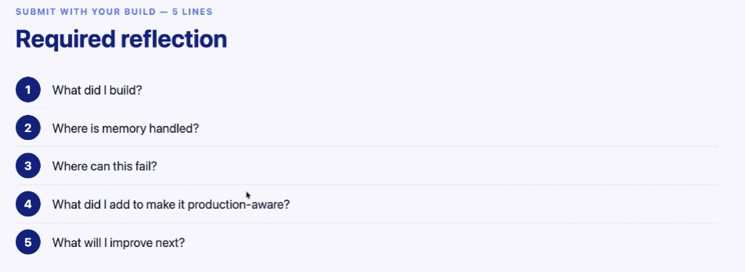

ZOOM CHAT
Abhijit Shah
11:20 AM
AS
I commit
Srihari Mogalapalli
11:20 AM

i commit
Ravi Singamsetty
11:20 AM

I commit
Utkarsh nigam
11:20 AM
UN
I commit
Balaji Punyakoti
11:25 AM
BP
I commit
Ayush Rawat
11:20 AM

Can you share the ppt covered in this session please?
Nag K
11:21 AM
NK
May I know when will be the next session?
S Aravinthan
11:21 AM
SA
Can you please share the code too in portal ?
Who can see your messages? Recording On
to:

